Aws SNS:

SNS provides this service to both application-to-person and application-to-application. It uses the publishers/subscriber’s paradigm for the push and delivery of messages. The data loss is prevented by storing the data across multiple availability zones. It is cost-efficient and provides low-cost infrastructure, especially to mobile users. It sends the notifications through SMS or email to an Amazon Simple Queue Service (SQS), AWS lambda functions, or an HTTP endpoint.

Benefits of using SNS

* SNS increases Durability.
* SNS increases Security.
* SNS ensures accuracy.
* SNS reduces and simplifies the cost.
* SNS supports SMS in over 200 countries.

**Clients of SNS**

* **Publishers:** They communicate with subscribers in an asynchronous manner by producing and sending a message to a topic (i.e a logical access point and communication channel). They do not include a specific destination (ex – email id) in each message instead, send a message to the topic. They only send messages to topics they have permission to publish.
* **Subscribers:**Subscribers like web servers, email addresses, Amazon SQS queues, and [AWS Lambda functions](https://www.geeksforgeeks.org/introduction-to-aws-lambda/) receive the notification over one of the supported protocols like Amazon SQS, HTTP/S, email, SMS, Lambda) when they are subscribed to the topic. Amazon SNS matches the topic to a list of subscribers who have subscribed to that topic and delivers the message to each of those subscribers.
* Amazon SQS is a web service that gives you access to a message queue that can be used to store messages while waiting for a computer to process them.
* Amazon SQS is a distributed queue system that enables web service applications to quickly and reliably queue messages that one component in the application generates to be consumed by another component where a queue is a temporary repository for messages that are awaiting processing.
* With the help of SQS, you can send, store and receive messages between software components at any volume without losing messages.
* Using Amazon sqs, you can separate the components of an application so that they can run independently, easing message management between components.

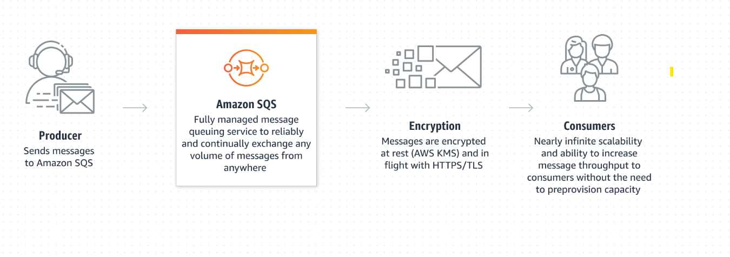

AWS Cloud Watch:

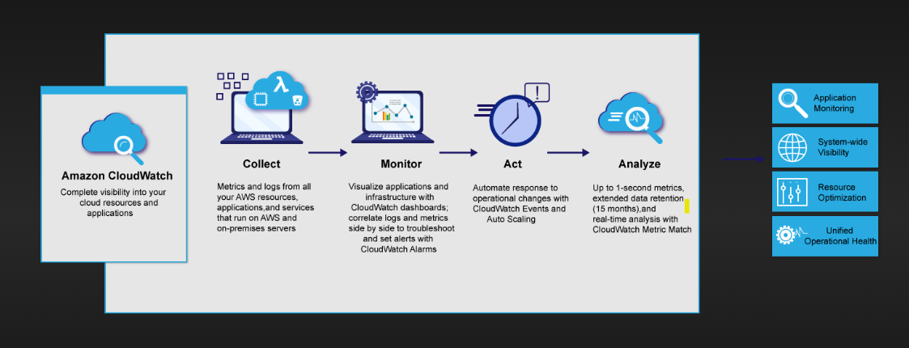

Collect, access, and analyze your resource and application data using powerful visualization tools.

Improve operational performance using alarms and automated actions set to activate at predetermined thresholds.

Seamlessly integrate with more than 70 AWS services for simplified monitoring and scalability.

## **Use cases:**

### Monitor application performance

### Perform root cause analysis

### Optimize resources proactively

### Test website impacts

### AWS CLOUD TRAIL:

### CloudTrail is enabled on your AWS account when you create it. When activity occurs in your AWS account, that activity is recorded in a CloudTrail event. You can easily view events in the CloudTrail console by going to Event history.

### Event history allows you to view, search, and download the past 90 days of activity in your AWS account. In addition, you can create a CloudTrail trail to archive, analyze, and respond to changes in your AWS resources. A trail is a configuration that enables delivery of events to an Amazon S3 bucket that you specify.

### 

### AWS CLOUD TRAIL USE CASES:

### Audit activity.

### Identify security incidents.

### Troubleshoot operational issues.

### AWS KMS :

### AWS KMS keys (KMS keys) are the primary resource in AWS KMS. You can use a KMS key to encrypt, decrypt, and re-encrypt data. It can also generate data keys that you can use outside of AWS KMS.

### 

### Use cases :

### Protect your data at rest : Activate server-side encryption with AWS KMS using KMS keys that you control and manage.

### Encrypt and decrypt data : Use the AWS Encryption SDK to securely handle cryptographic operations in your applications.

### Sign and verify digital signatures : Protect signing operations with AWS KMS using asymmetric KMS keys.

Build secure multi-tenant databases **:** Use the AWS Database Encryption SDK to easily encrypt and securely search sensitive records in your databases.